At the end of this worksheet, you should be able to

* to discuss the relationships between the quantities of work, energy, displacement, velocity.
* differentiate between a conservative force and a non-conservative force.
* apply the work energy theorem to solve interesting problems that would be hard to use Newton’s Laws.
* discuss the principle of conservation of energy and explain when it is useful.

1. *Work* is defined as a transfer of *energy*. This transfer occurs by one object exerting a force on another object *over some displacement*. But the relative directions of these two vector quantities (force and displacement) matters. Summarize the work done in 5 different cases that are represented below by drawing the object and the vectors representing force *⃗F* and displacement Δ*⃗x*. In each case I have provided a simple example to illustrate what I mean. You provide another one.
   * + The force and displacement point *in the same direction*. (I push a box across a level floor with 100-N force over a displacement of 10 m).
     + The force and displacement point *in different directions, but the angle between them is less than 90°*. (I pull a box 10 m across a level floor with a 100-N force, directed at an angle of 37° with respect to the floor.)
     + The force and the displacement are *perpendicular* to each other. (A 10 kg box is sliding across a rough surface with friction, and the normal force is acting on the box.)
     + The force and displacement point in *different directions and the angle between them is greater than 90°*. (I bring a sliding box to a stop by exerting a 100-N force on it at an angle of 37° with respect to the horizontal.)
     + The force and displacement point in *opposite directions (anti-parallel)*. (I bring a sliding box to a stop by exerting a 100-N force over 10 m. Friction)
2. A person lifts a 100-kg object 1 meter off the ground.
   1. What amount of work is done by the person?
   2. What amount of work is done by the force of gravity?
   3. If the person drops the box, what amount of work would the force of gravity do on the box as it fell?
3. A black background with a black square

   Description automatically generated with medium confidenceAn object sliding across a *frictionless* surface approaches a *frictionless* ramp and begins to slide up it. The force of gravity does negative work (removes energy), and the object slows down to a maximum height, d, before sliding back down. The ramp has an incline angle of 20° with respect to the horizontal.

Calculate the work done by the force of gravity and see that it is a negative value in three ways:

* 1. What is the angle between the displacement and the force of gravity? Use this angle and the definition of work to calculate the work.
  2. What is another angle between the displacement and the force of gravity? Now use this angle and the definition of work to calculate the work.
  3. What is the *component* of the force of gravity that is in the direction of the displacement? Now use this angle and the definition of work to calculate the work.

1. Identical boxes are either dropped or slide down different frictionless inclines. The boxes are all identical, and the distance down the incline, and angle of the incline are given.
   1. Rank the work done by gravity in each case from greatest to least.
   2. Rank the time to strike the ground in each case from shortest time to longest time.
2. What amount of work is required to push a 100-kg object up a *frictionless* inclined plane that is 10 m long, and its end is 1 meter high at constant velocity? How does this compare to the work done to lift it? Show that this can be used to derive the formula $\frac{F_{push}}{weight}=\frac{height}{d_{plane}}$
3. *Kinetic energy* is the energy of an object that has velocity. *K* = ½ *mv*2
4. Calculate the kinetic energy of a 10 kg object that has a velocity of 10 m*/*s.
5. If you do some work to *double* the velocity of the object, what is the new kinetic energy?
6. What is the ratio of the kinetic energy final to the initial kinetic energy?
7. What is the *change* in kinetic energy?
8. How much *work* would be required to cause this change in kinetic energy?
9. What is the magnitude of a force that acts parallel to displacement and moves the object 10 meters?
10. A 5-kg object, initially at rest, is pushed by a 100-N force over a *rough* surface with friction for 10 meters. The object moves with constant velocity of 1 m/s.
    1. What is the work done by the force?
    2. What work has the force of friction done?
    3. What is the net work done?
    4. What is the kinetic energy initially?

* 1. Does the kinetic energy change?
  2. What power am I providing?

1. A 10-kg object, starting from rest, is pulled by a rope at an angle of 20° to a horizontal along a *rough* surface for 100 meters. The tension in the rope is 100 N, and the coefficient of kinetic friction between the floor and the object is *μ* = 0*.*1.
   1. What work is done by the rope?
   2. What work is done by the force of friction?
   3. What work is done by the normal force?
   4. What work is done by the force of gravity?
   5. What is the net work done on the object?
   6. What is the change in the object’s kinetic energy?
   7. What is the object’s final velocity?
   8. What is the net force on the object?
   9. Using the net force, what is the net work done on the object?
2. What forces are conservative forces and what are not conservative forces?
3. A 10-kg object is 10 m above the ground.
   1. What is its potential energy?
   2. If it begins it to fall, what is its potential energy after it falls 1 m? What is its kinetic energy at this point?
   3. What is its kinetic energy when it hits the ground? Calculate its velocity at this point.
   4. Demonstrate this in the bar graphs below.

|  |  |  |  |
| --- | --- | --- | --- |
| at 10 meters | At 9 meters | At ground level |  |

1. An object falls from a height of 100 m then how fast is it going when it hits the ground?

Solve this using kinematics and then again using conservation of energy?

1. 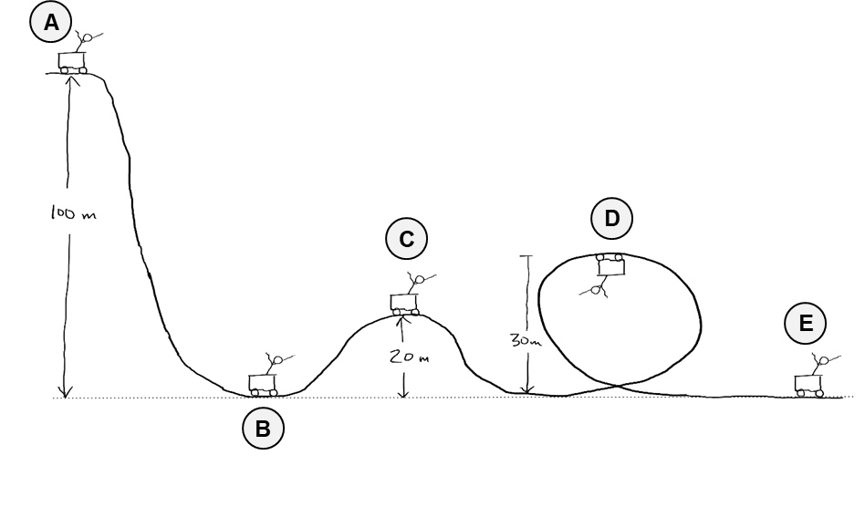A roller coaster starts from rest at the top of a hill and rolls down its course. Find its kinetic and potential energy at each position marked. Assume no friction.

|  |  |  |  |
| --- | --- | --- | --- |
| A black background with a black square  Description automatically generated with medium confidenceA | A black background with a black square  Description automatically generated with medium confidenceB | A black background with a black square  Description automatically generated with medium confidenceC | A black background with a black square  Description automatically generated with medium confidenceD |

1. What is the minimum height *h* that a roller coaster needs to start at rest to successfully complete a loop-the-loop of radius *r* and not lose contact with the track?
2. A 10-kg box slides down a *rough* inclined plane (*μ* = 0*.*1*, θ* = 30°). The height of the plane is 1 m above the horizontal.
   1. What is the speed of the box at the bottom of the plane?
   2. How does this compare to if there were no friction? How much work has been done by the force of friction?
3. Here is an example of a problem that would be much more difficult to do with Newton’s Laws. Take the same inclined plane as the problem above but make *most* of the plane *frictionless* and only a 10 cm portion in the middle of the plane have friction *μ* = 0*.*1. Now what is the speed at the bottom of the plane? Think about how you would have solved this using Newton’s Laws and kinematics.
4. Three identical balls are tossed from the top of a building at the same speed. Ball A is tossed horizontally, Ball B is tossed upward at a 45o angle, and Ball C is tossed downward.
   1. What is each ball’s total mechanical energy at the top of the building immediately after the toss?
   2. What is the speed of each ball as it strikes the ground?
   3. Will energy tell us when the ball lands?
   4. Will energy tell us how far each ball lands from the base of the building?
5. A soccer ball is kicked across a field with a velocity of 5 m/s at a 37o angle above the horizontal. How can you determine the maximum height of the ball using energy?
6. A 100 kg cyclist (and bike) has at constant speed of 10 m*/*s up an incline of 5% (vertical height/horizontal distance as a percent). What power output does the rider need to provide to do this?
7. The maximum speed of a child on a swing is 5 m*/*s. At this point the child is 1 m above the ground. What is the maximum height of the child above the ground? Do this two ways, once with *Ug* = 0 at the ground, and once again with *Ug* = 0 at the bottom of the swing’s path.
8. A pendulum swings from some maximum height where its velocity is zero to a minimum where is velocity is a maximum and then back up to a maximum height. If the maximum height is 0.1 meters above the minimum height, then what is the speed of the pendulum at the bottom of its swing?
9. 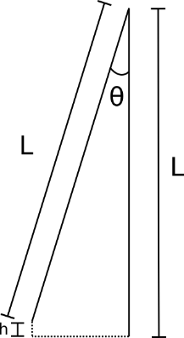For a pendulum, it is hard to measure its maximum height, but it is easy to measure its length and to measure its angle from the vertical. If the maximum angle from the vertical of a 1 m long pendulum is 20° then how high is this above the horizontal? (*Hint: draw a line from the end of the pendulum when it is at its maximum height perpendicularly to the line when it is at is minimum height.*)
10. 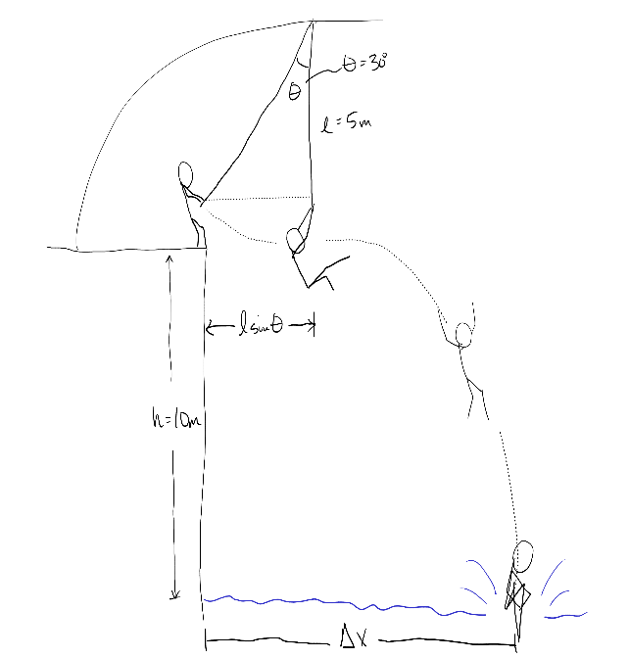If you are doing a rope swing and then at the lowest point in the swing you let go and drop into a lake below, how far from the edge of the cliff do you land in the water. See the diagram below for the relevant parameters.
11. 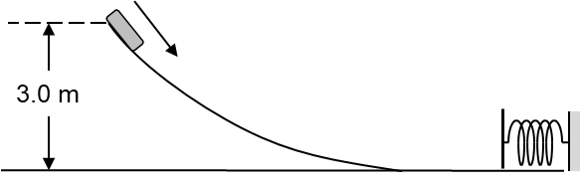A 2-kg mass rests at the top of a frictionless curved ramp 3 meters above its base. The mass slides down a frictionless curved ramp and strikes a spring with a spring constant k = 20 N/m. What distance is the spring compressed when the block comes to rest?